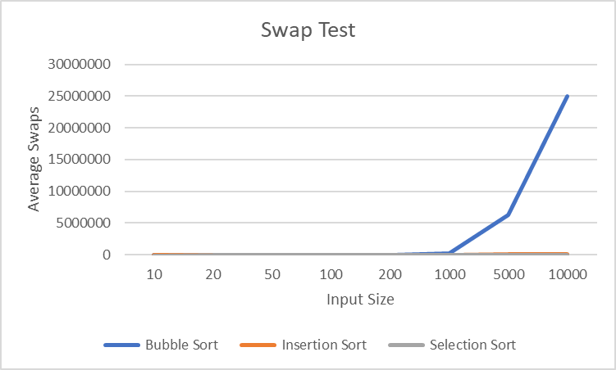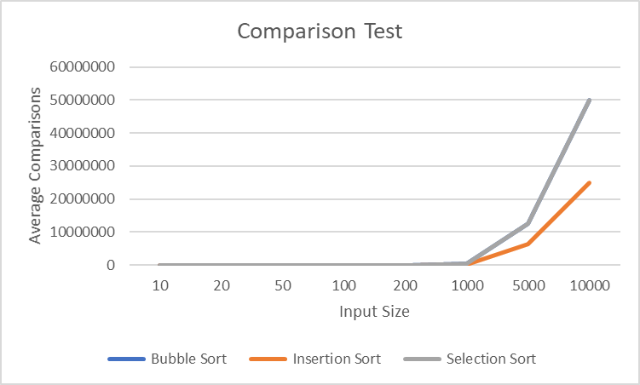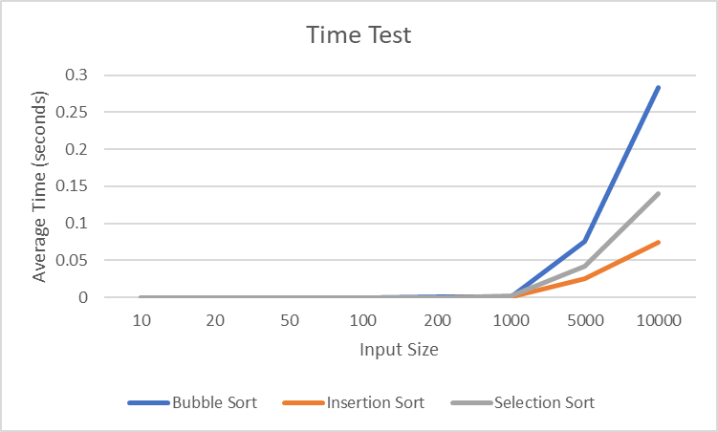1.

2. Insertion Sort, since insertion sort stops swapping for the current iteration when the condition fails while both bubble and selection sort compare through each element before stopping for the current iteration, taking time.

3. Insertion Sort, since comparison stops once the condition is not met while both bubble and selection sort compare through each element before stopping for the current iteration.

4. Selection Sort, since a swap only happens when all elements have been compared to one another, while both bubble and insertion sort needs to compare and swap most of the time.